**JKUAT-KSA Small Scale Agriculture Crop Mapping Project**

**CROMAP User Guide**

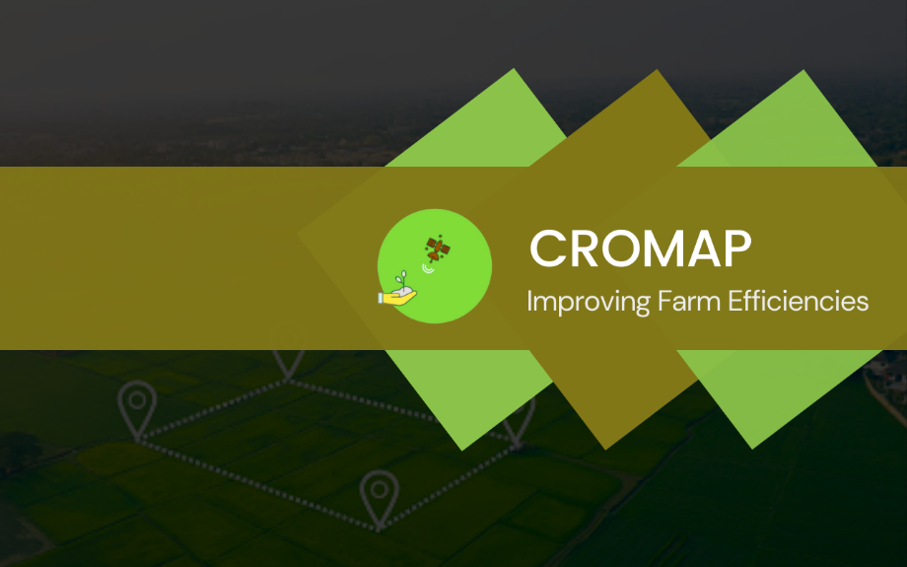

Welcome to the CROMAP web application.

This is a platform that helps you digitize all the farm activities

and analyze the performance of your crops

at the comfort of your screen.

**cromap**

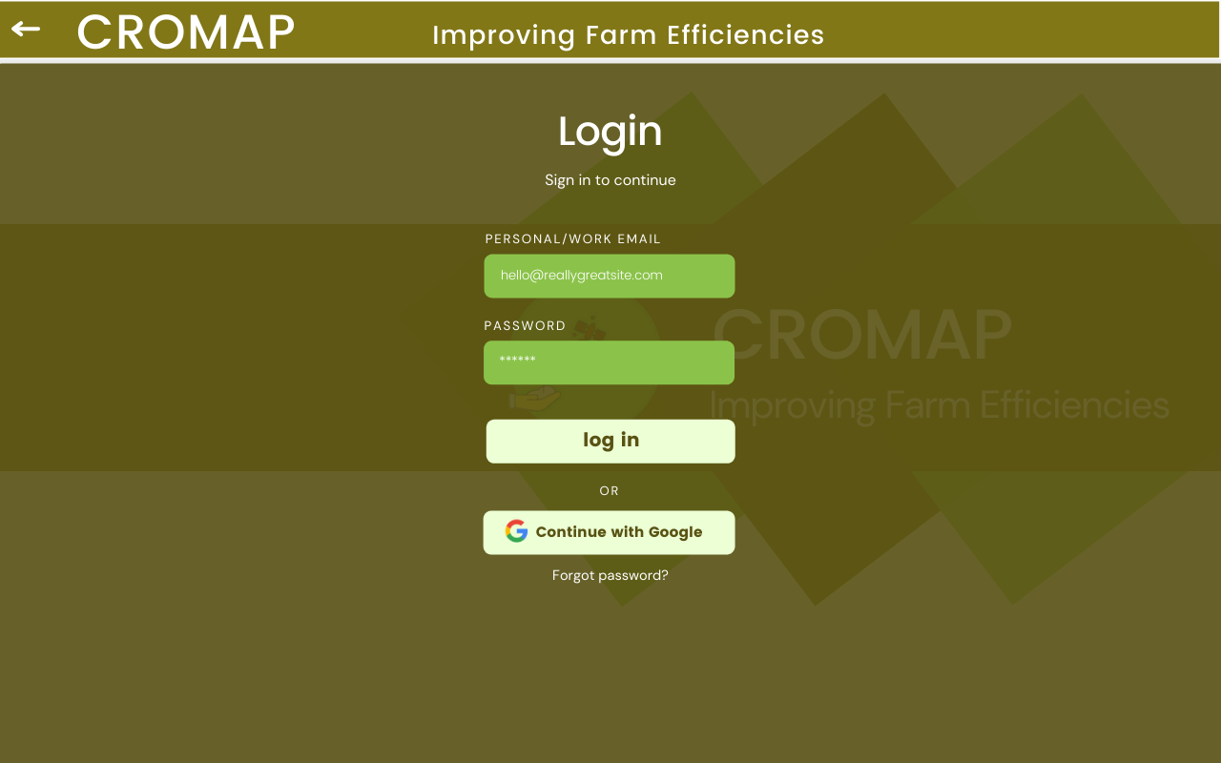

Improving Farm Efficiencies

**Web Application**

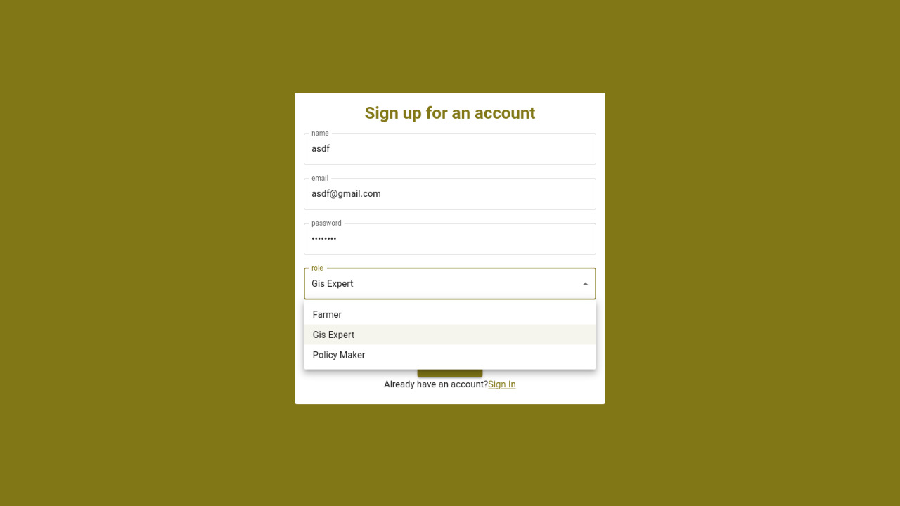In order to use CROMAP, you will need to create an account. Fill in your credentials and specify whether you are a farmer or a professional, in order to access relevant app functionalities.

If you already have an account, click on sign in and enter your email address and password. 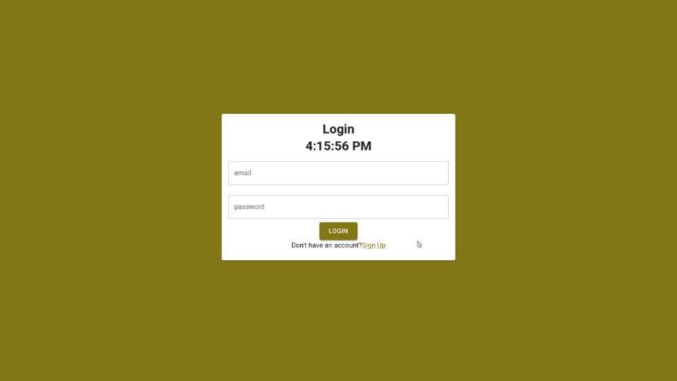

after logging in, you will be redirected to the following screen:

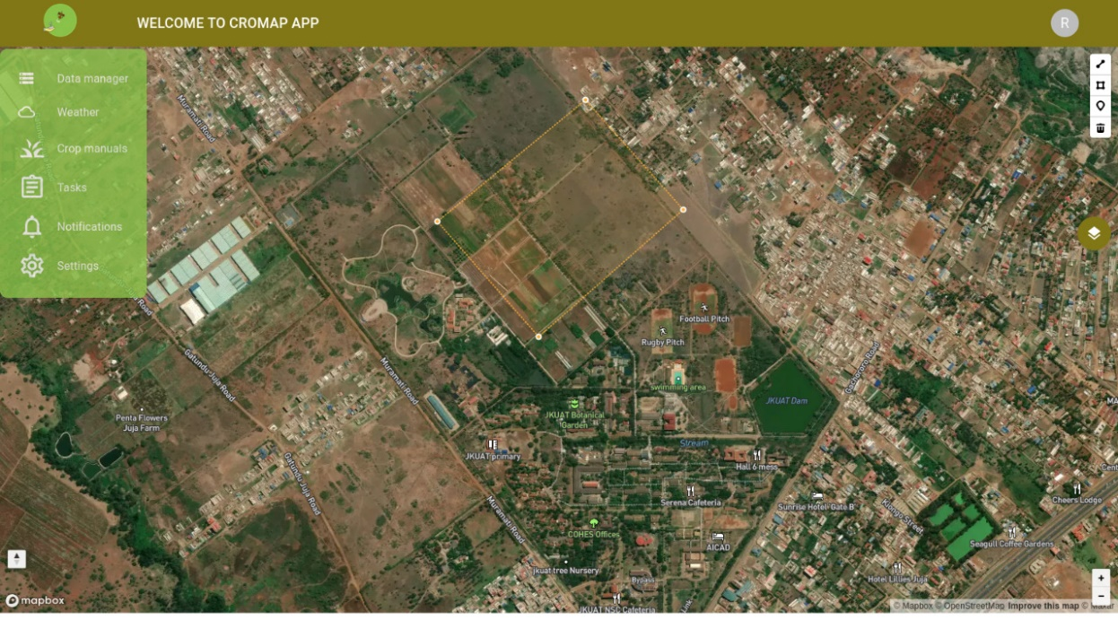

There are several icons to help you navigate the map. For example, zoom and pan functions, draw field and measure distance, and select icons. In the settings section, you can edit your profile and change your details.

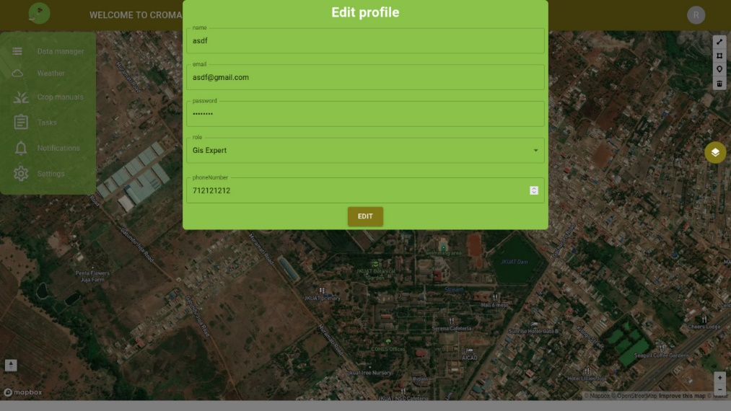

Upon clicking on the layers icon, you can switch between satellite view, streets or navigation mode.

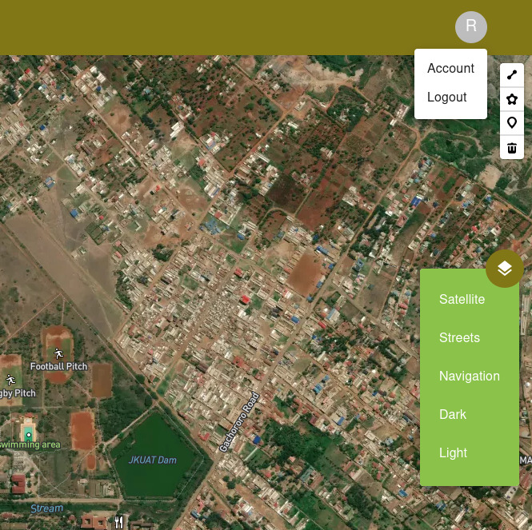

Import/Export Functions

The data manager drop-down menu allows you to view fields and field notes, or import and export data within the application. Acceptable file formats include .tiff, shape files and KMZ files. You can also upload images taken from your farm. Importing large files may be done by uploading them as zipped files.

Weather Forecast

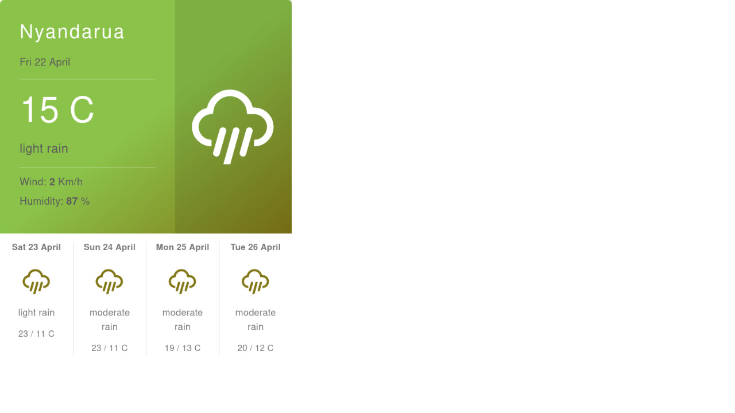

The weather icon allows you to view current and future weather forecast, as well as weather history. At the crop manuals section, you can access videos that provide more guidance on best farming practices. The videos can also be downloaded for offline viewing.

Farm Collections

The vegetation map allows you to explore crop land areas with different yield capacities, view changes in area under cropland and visualize the extent of water stress on the farm. Under the collections section, you may create new collections or archive and manage existing collections. Created tasks and imported data for each farm project can be stored under a collection.

Adding Fields

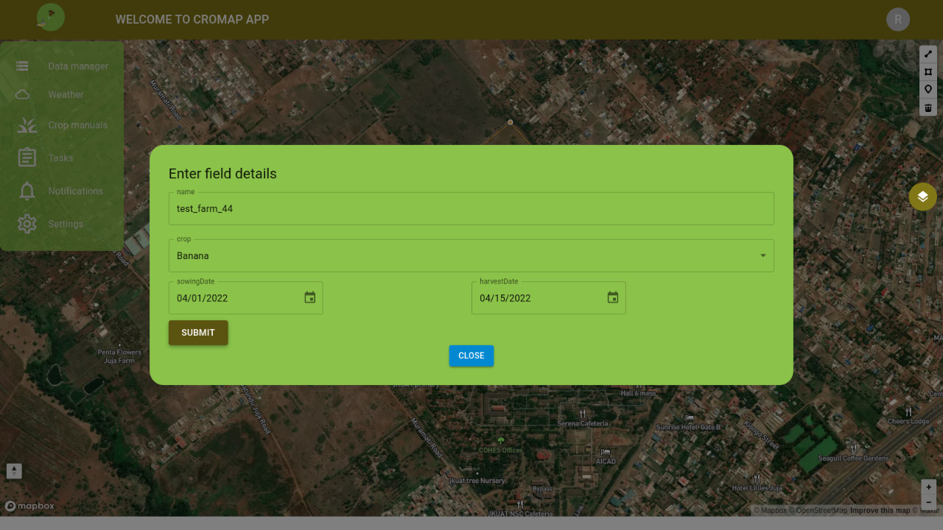

To draw a field on the map, click on the polygon icon and start tracing the boundary of your farm. In case you draw the boundary wrongly, you can edit the vertices and correct it. Once you are done, click on “add field”. You will be prompted to fill in some details about the farm, then it will be registered by the system. “Select Date” allows you to select a time period for the crop performance analysis and precipitation data.

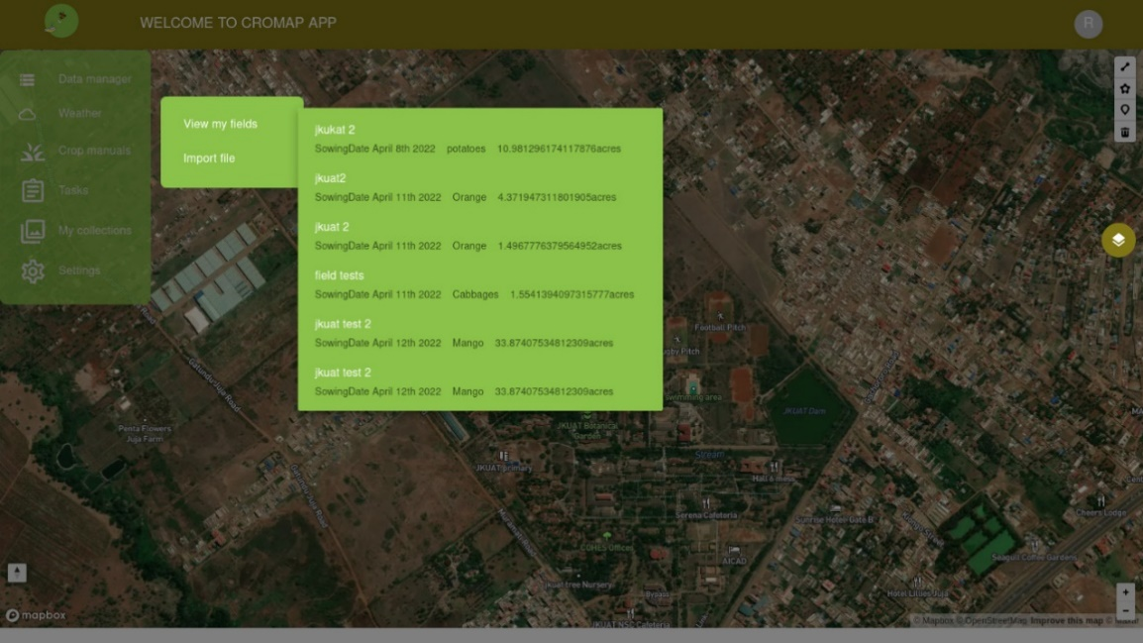

You can also view the fields you have created on CROMAP by clicking on ‘View my fields’.

Creation of Tasks

Once you click on the ‘tasks’ icon, there are options to create a new tasks, view existing tasks and drafts among other options.

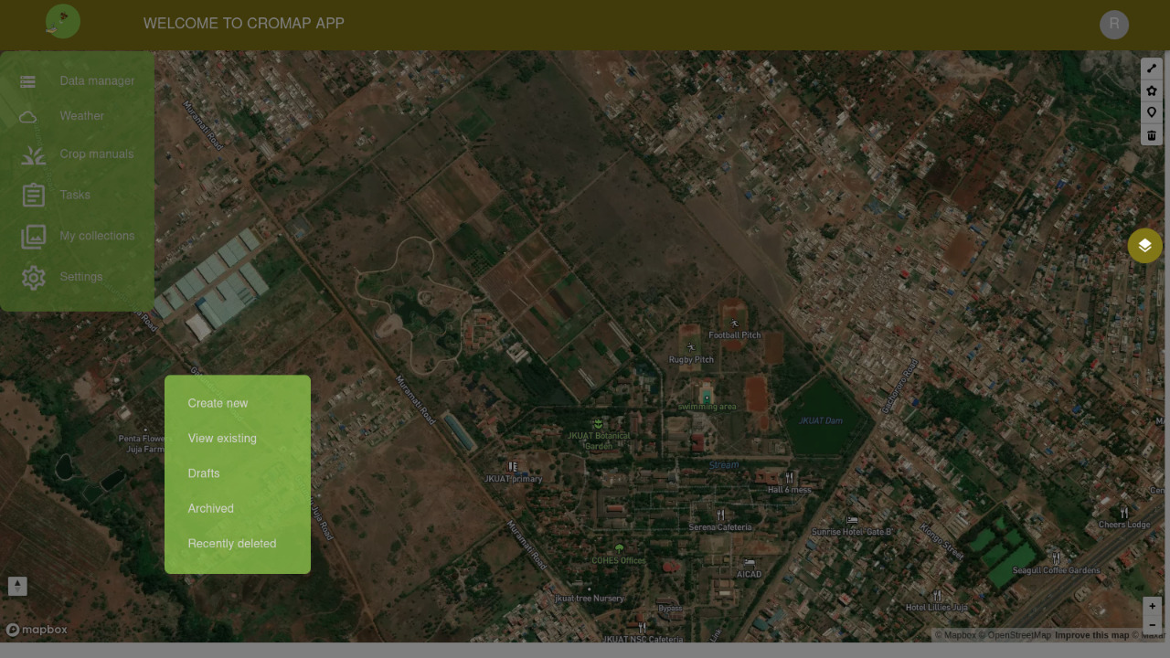

The attached crop manuals cover the following areas: land preparation, planting, spraying pesticides, fertilizer application and top dressing, field scouting, harvesting, best farming practices for potatoes, peas, other crops (tree tomatoes, carrots, cabbages and onions).

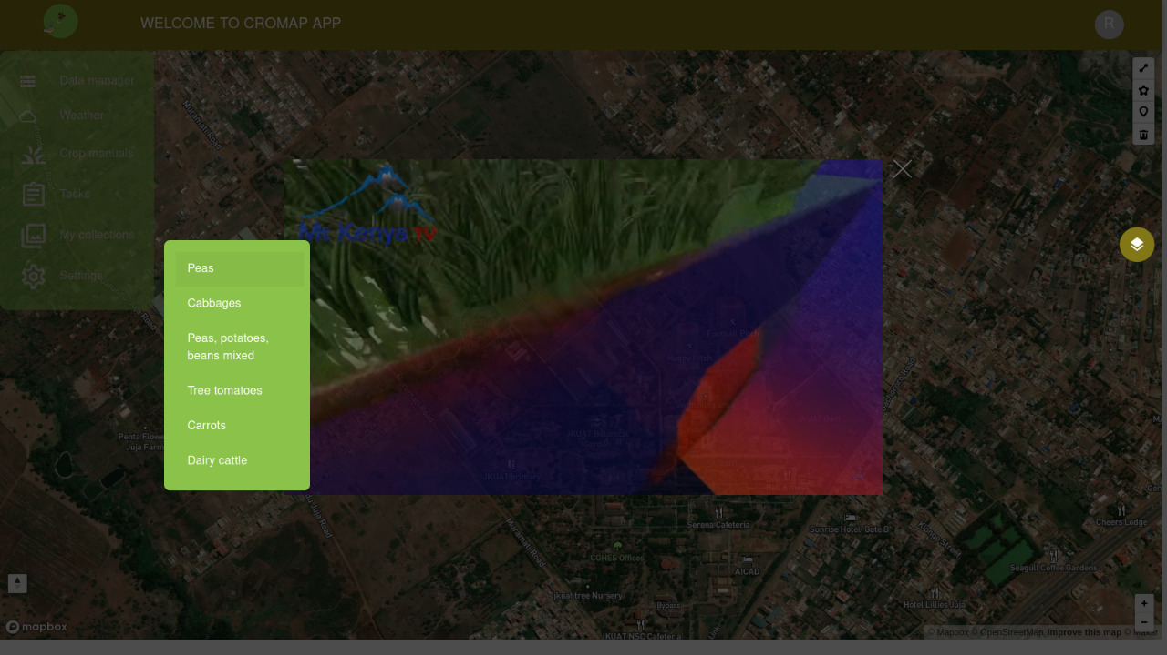

The CROMAP web application allows you to calculate several indices, such as NDVI,NDRE, and MSAVI among others for both Sentinel-2 and Landsat 8 satellite imagery. These indices can help you monitor the health of crops on your farm. For example, higher NDVI values represent healthy crops while low values represent crops under stress.

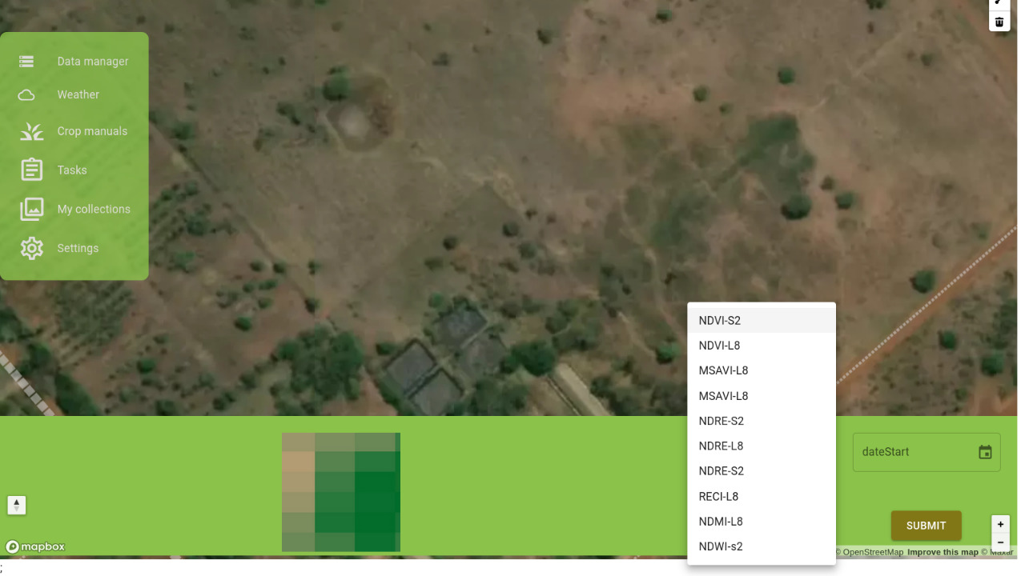

**Mobile app guide**

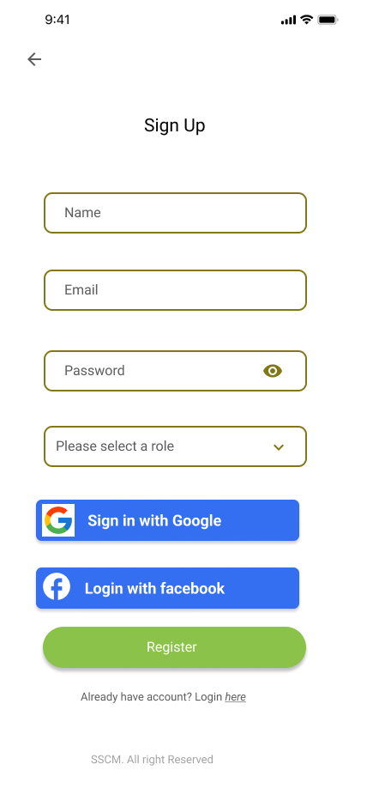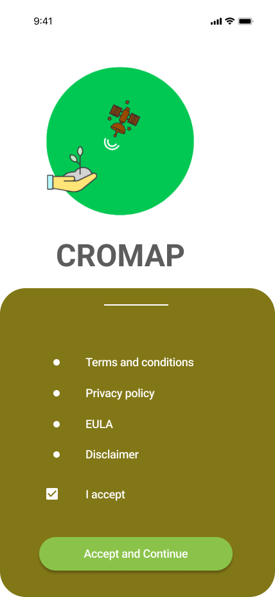

To use the CROMAP mobile application, create an account by filling in the required credentials. You can also sign in with Google or Facebook. Specify whether you are a farmer, policy maker or GIS specialist, then accept the terms and conditions in order to complete the sign up process.

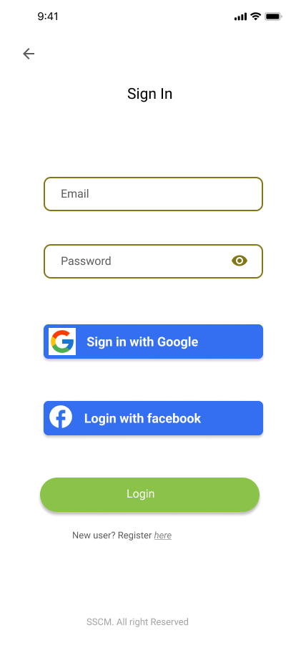

The login page allows you to access CROMAP homepage through your new account.

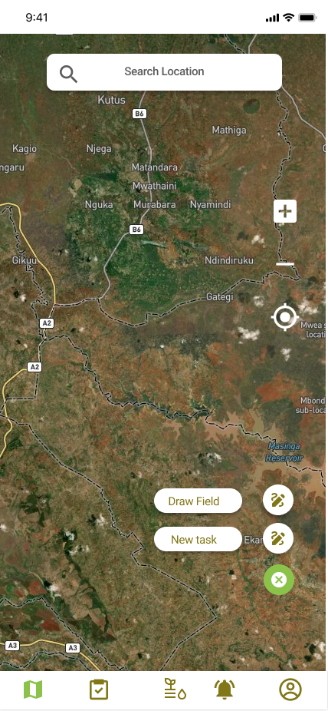

On the Homepage screen, there is a floating action button with a ‘Draw Field’ function to draw a polygon for defining the boundary of your farm. The ‘New Task’ button allows you to create a new farm task.

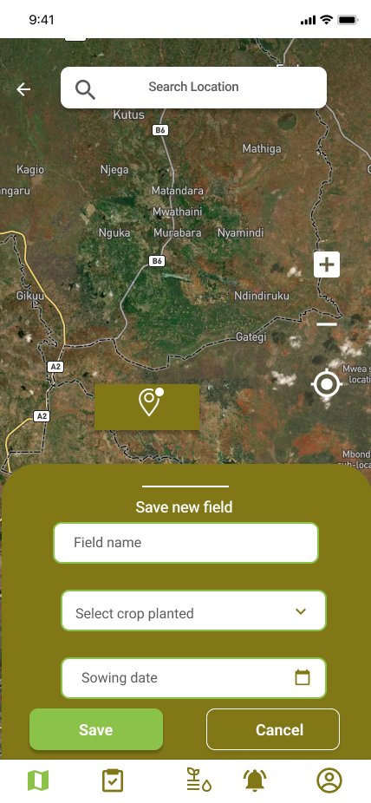

Once you draw a field, a pop up dialog box prompts you to fill in the field name, name of the crop(s) and the date range whose information you would like to view. There is also a geolocation feature on the screen to center the map on your current location.

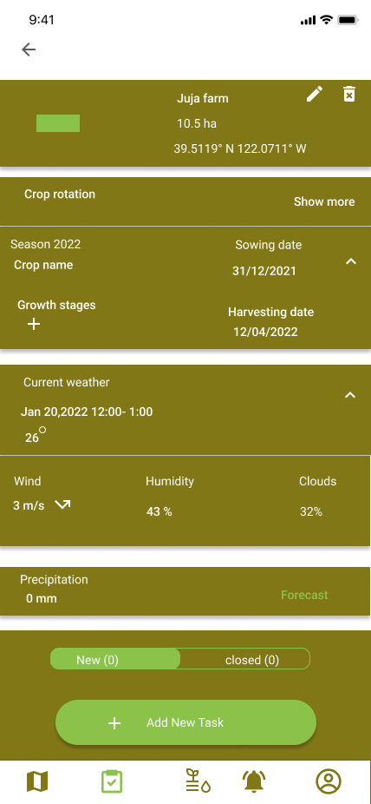

You will be led to another screen with information on the weather forecast and precipitation. There are slots to add more crops, growing timelines and harvesting dates.

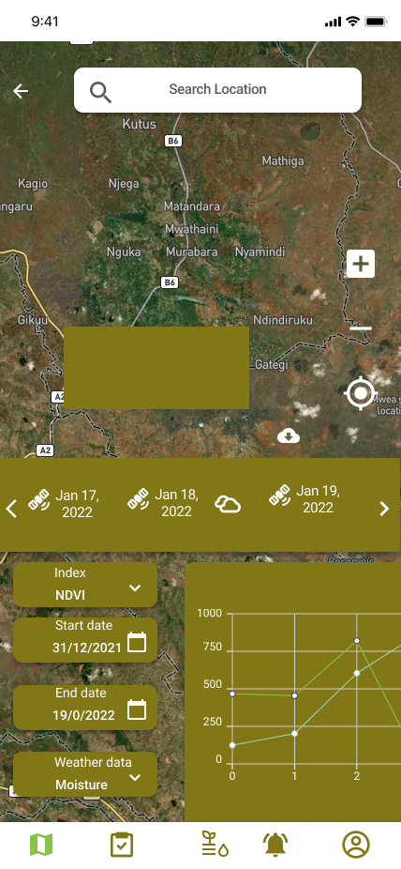

You will then be redirected to the home screen to view vegetation indices and charts reflecting the progress of crop health for your selected time period.

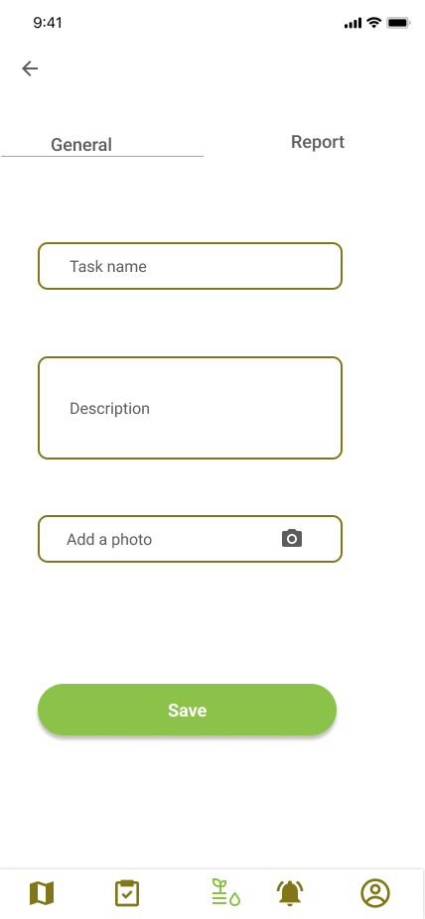

On clicking the ‘New task’ button on the homepage, you will be required to fill in the name and description of the task. You may also add a photograph of the task.

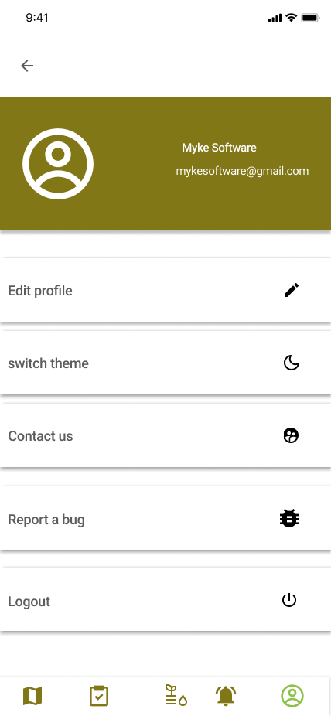

The profile section allows you to edit your profile, switch color themes, report a problem, contact an expert or sign out of the application.